Recruitment Dashboard

select ZO.posting_title, ZO.priority, count(ZA.candidate_id) as candidates, count(ZI.candidate_id) as intweviewees, count(ZI.id) as interviews

from [RecruitmentLakehouse].[dbo].[zoho_jobopenings] ZO

LEFT join [RecruitmentLakehouse].[dbo].[zoho_applications] ZA on ZA.job_opening_id = ZO.id

LEFT JOIN [RecruitmentLakehouse].[dbo].[zoho_interviews] ZI on ZI.job_openings_id = ZO.id

WHERE ZA.created_time BETWEEN '01-11-2024' AND '30-04-2025'

and ZO.job_opening_status = 'In-progress'

and ZI.start_datetime BETWEEN '01-11-2024' AND '30-04-2025'

group by ZO.posting_title, ZO.priority

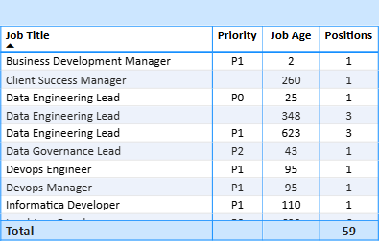

SELECT

    ZO.posting_title as job_title,

    ZO.priority,

   -- DATEDIFF(DAY, ZA.created_time, GETDATE()) AS KPI1,

    ZO.number_of_positions AS positions,

    COUNT(DISTINCT ZA.candidate_id) AS Applied

FROM

    [RecruitmentLakehouse].[dbo].[zoho_jobopenings] ZO

LEFT JOIN

    [RecruitmentLakehouse].[dbo].[zoho_applications] ZA

    ON ZA.job_opening_id = ZO.id

LEFT JOIN

    [RecruitmentLakehouse].[dbo].[zoho_interviews] ZI

    ON ZI.job_openings_id = ZO.id

WHERE

    ZO.job_opening_status = 'In-progress'

   -- AND ZA.created_time BETWEEN '2025-04-23' AND '2025-04-30'

GROUP BY

    ZO.posting_title,

    ZO.priority,

    ZO.number_of_positions

   -- ZA.created_time

ORDER BY

    ZO.posting_title;